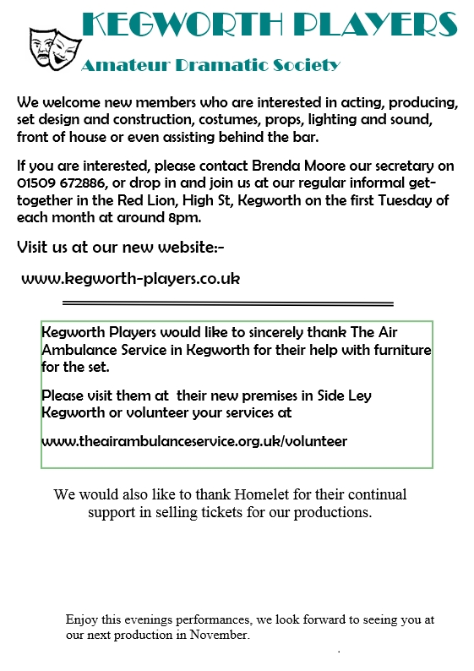

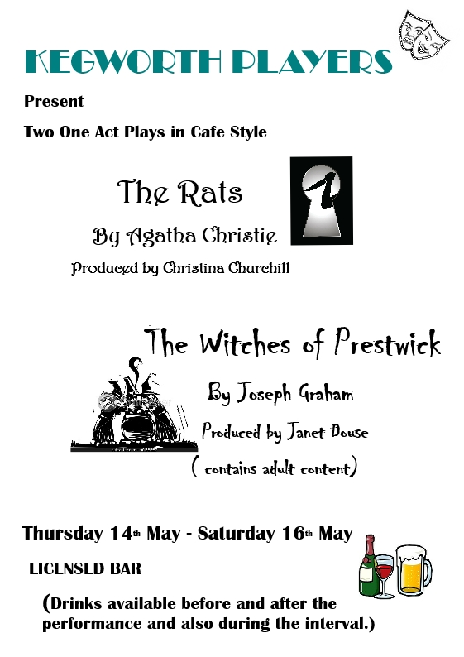

Thanks and Dedication

We would like to express thanks to our parents, family, and friends for all their love and support. Thank you all for sharing this special day with us.

Twenty-First of June, 20XX

At Eleven O’clock

Location of the Event

The Marriage Celebration of

Bride’s Full Name

And

Groom’s Full Name

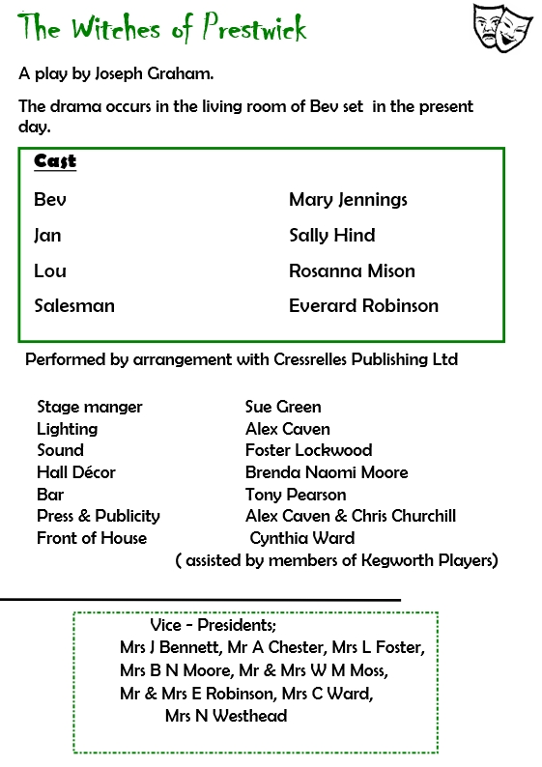

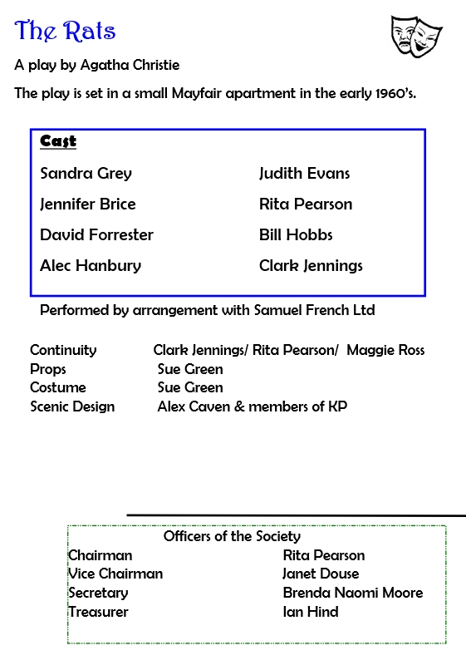

Additional Text

Type a quote

Or a poem

about marriage

here

The Ceremony

Prelude

Processional

Opening Words

Readings

Declaration of Intent

Exchange of Vows

Exchange of Rings

Declaration of Marriage

Blessings

Recessional

Additional Text

Readings

Hymns

Poems

Wedding Participants

Officiant(s)

Parents of the Bride

Parents of the Groom

Maid/Matron of Honor

Best Man

Bridesmaids

Groomsmen

Reader(s)

Musicians